Notice the contrasting colors of text and background.
To stomp out forest fires.
Why do ducks have flat feet?

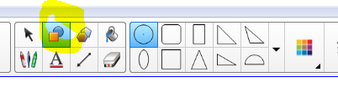
If you make a text box with the question one color (different than the background) and the answer another color (same as the background) then move the text box on the Smartboard to the other background, that contrasting color with the correct answer will be revealed.
- Draw a shape.
- Clone or copy the shape. Right click or down arrow. Clone or Copy/Paste.
- Make sure you put away your shape tool and pick up the select tool. (arrow)
- To change the color of the line and the fill –
  - Right click or down arrow 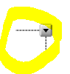
  - Select Properties
  - Select Line Style or Fill Effects.
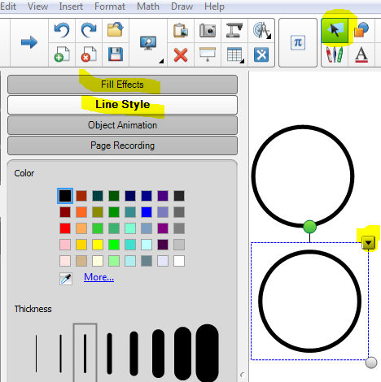
  - Select contrasting colors that will complement each other and show up well on the Smartboard. You want your students to be able to read the words.
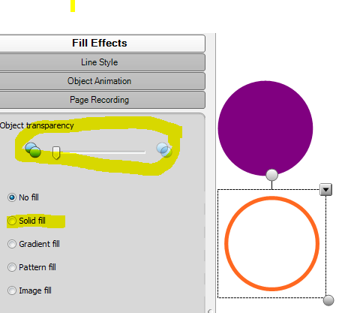
  - You will have to select each object twice to change the fill and the outline.
  - Notice this is also where you can make objects transparent.
  - Place the objects where you want them on the page.
  - Text – Grab your text tool and make the text box small enough to fit in the object.
  - Type your joke, antonym, math problem, whatever. Notice that the orange and purple is not really a good combination.
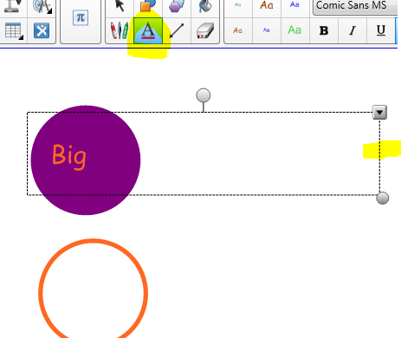
  - Do the same for the other object.
  - Space your words so that the second one doesn’t show while you students are seeing the first one.
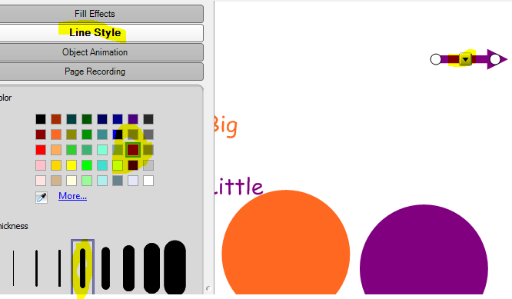
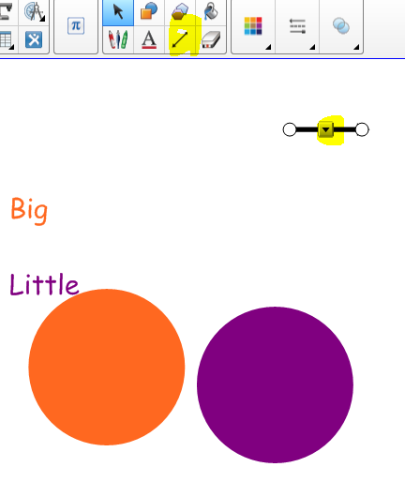
  - Add an arrow to direct users. Use the straight line tool with the arrow at the end. Right click to go to properties to choose the size and color of the arrow.

  - Rotate the arrow to the direction you want it. Using the select tool, draw a rectangle around the text box and the arrow. Right click and choose Grouping. Then Group.
  - Using the Select tool, draw a rectangle around the colored shapes. Select Properties, group them together and lock into place. You do not want them inadvertently moved.
  - Move the text grouped with the arrow into place.
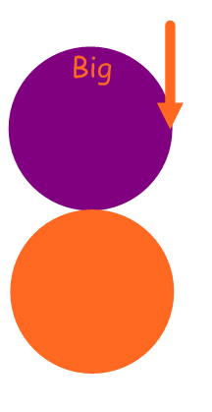
  - When you pull down the arrow you will see the opposite word appear.
