Finshing Up
- Make sure you lock your text and graphics. That way, kids can’t move them around inadvertantly and it will save you work if your file gets saved with all the unwanted changes.
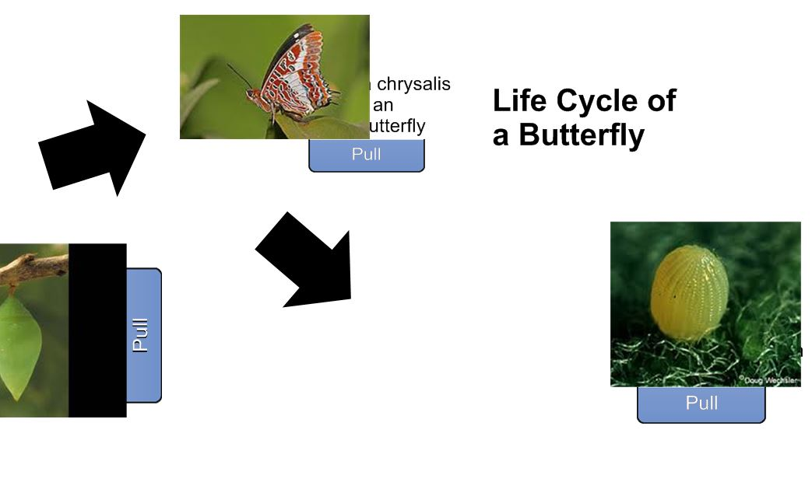
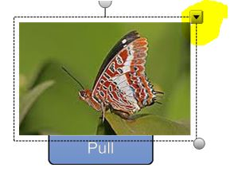

- Use the down arrow to find the locking choice.
- Once an object has been locked, no changes can be made until it is unlocked.
- Unlock the object, make changes such as text, colors, order, behaviors.
- Lock or Lock/Allow Move – Lock makes the object (including text) fixed in position. Lock/Allow Move, allows the object to be moved but not rotated.
- Notice the penguin is covering Danielle’s name. Use the down arrow to change order. Think of it as layering.

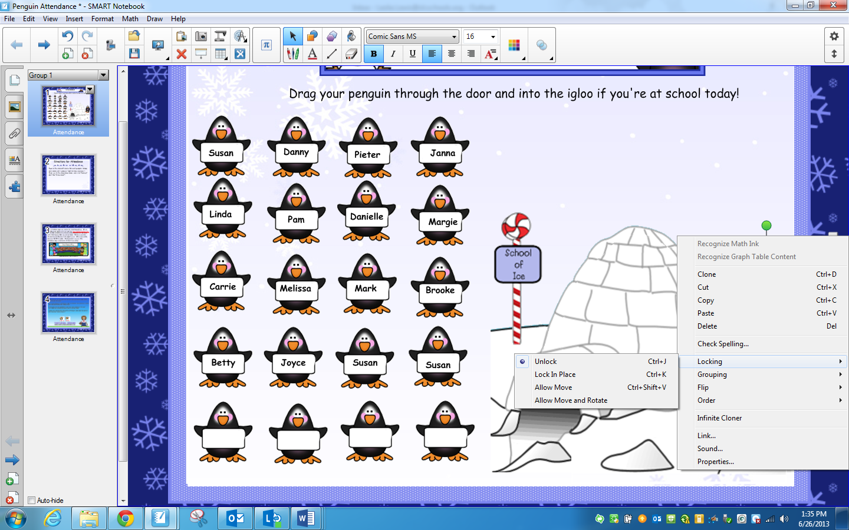Locking objects
You can lock an object to prevent its modification, movement or rotation. Alternatively, you can lock an object but allow its movement or its movement and rotation.
You can remove this lock at any time.
To lock an object
- Select the object.
- Press the object’s menu arrow, and then select Locking > Lock in Place.
You’re unable to move, rotate or modify the object until you unlock it.
NOTE
If you press a locked object, a lock icon appears instead of a menu arrow.
To lock an object but allow its movement
- Select the object.
- Press the object’s menu arrow, and then select Locking > Allow Move.
You can move the object but you’re unable to rotate or modify it until you unlock it.
NOTE
If you press a locked object, a lock icon appears instead of a menu arrow.
To lock an object but allow its movement and rotation
- Select the object.
- Press the object’s menu arrow, and then select Locking > Allow Move and Rotate.
You can move and rotate the object but you’re unable to modify it until you unlock it.
NOTE
If you press a locked object, a lock icon appears instead of a menu arrow.
To unlock an object
- Select the object.
- Press the object’s lock icon , and then select Unlock.

