3:30 – 3:45 - Welcome – Name cards -
3:45 – 4:10 – Holiday Snowman Kooshball -
4:10 – 4:45 – Seasons - Activity Builder –
- Tutorial - Video
- Building your own
4:45 – 5:15 – Tiles Activity –
- Video
- Build your own
5:15 – 5:45 – Recording Stories -
- Video – Moon Guy
- Video – How to Record
5:45 – 6:00 –
- Clarify Homework
- Questions?
- Evaluation
Homework – Due January 31, 2013 –
Submit attachments to my email please. Leslie.lewis@slcschools.org
I will be posting these homework activities to the Weebly so that others may use them and you may use those of others.
- Tweak a template from the Gallery or Smart Exchange and make it your own – your grade level, content, colors, etc. We are going to post them. They need to be sufficiently different from the original so as not to violate any copyright.
- Build a 1 page Smart Notebook Lesson from scratch! It needs 5 interactions such as a
  - Video
  - Tab
  - Animated object
  - Color reveal
  - Background
Helpful Pointers-.
- Remember to put away your tool and pick up the Selector tool. This is the hardest thing to remember and often very frustrating when you can’t figure out why you keep getting a text box.
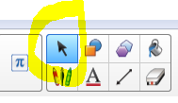
The selector tool looks like your cursor or arrow.

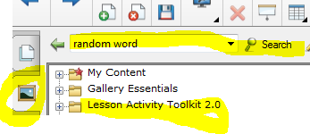
- The Gallery looks like a framed picture.
- Type a topic in the search field after clicking on Gallery to find what you are looking for.
- Lesson Activity Toolkit 2.0 has lots of examples, templates, and pieces of pages like backgrounds and tabs.
- Weebly Address - http://virtual225.weebly.com/sleekersavvysmarter.html

