- Go to Gallery
- Type Question in search field
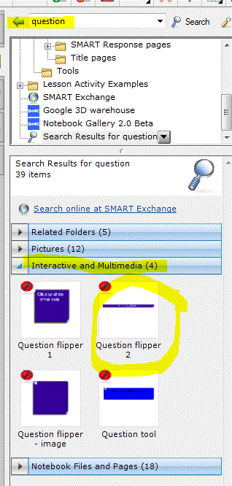
- Choose Interactive and Multimedia
- Issue – this software is hinky. The graphics are sticky and hard to manage.
- Click on the arrows on the left side of the bar. Here is where you will edit
  - Font
  - Color
  - Question
  - background

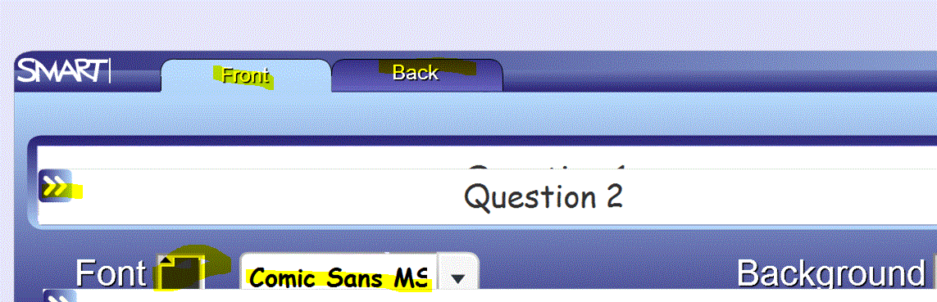
- Notice how the bars sort of overlap each other. Just work around the nuisance factor. Change the font color, style, and the background color. Notice the tabs on the top for Front and Back. That is where you change the words on the bar.
- Be sure to choose OK or Cancel which may be mostly covered up by the overlapping second bar. Remain calm. You can beat the software.
- On the bottom right of each bar there is a triangle with 3 diagonal lines through it. This is where you are supposed to be able to enlarge or shrink your bar. However Yoda, the hinkiness is very strong here.
- To add the vote tool, just go to Search
  - Vote tool 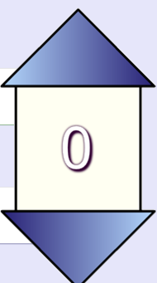
  - Interactive and multimedia
  - Drag it over.

