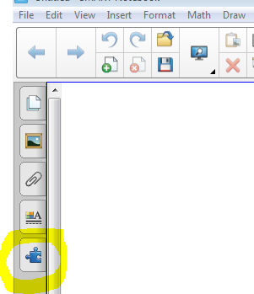
- Click on the jigsaw puzzle piece.
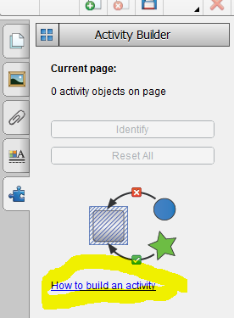
- Click on “How to Build an Activity”
- Read through.
- If you need more information, click on the button that says “More information”.
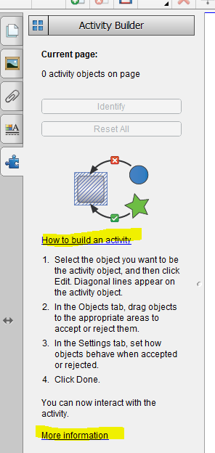
- 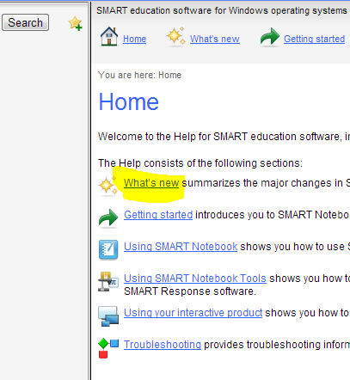
If you click on “What’s new”, you will find information to assist you.
- Chose “Using the activity builder”.
- Here you will find a little video tutorial.

