- In Excel find the averages of scores or each subject for each student.–
  - Go to end of column and >Editing tab >click Auto sum arrow >click Average-ENTER;
  - Click back into average box and in lower right corner of cell left click and drag to copy formula
  - To reduce decimal number highlight column-right click-select: format cells, select: number, select: decimal places)
  - Make a new Excel document- save it. You will need it.
  - Copy and paste names and averages into that document
  - Close the document.
- Create a word document – Name it and save it.
  - Insert a table
    - Select: Insert, Select: Table. Choose appropriate columns and rows.
Name
Math Average
Science Average
Spelling Average
Date

  - Click tab: Mailings (located at top of ribbon)
  - Click arrow: Start Mail Merge
  - Click: Step by step mail merge wizard
  - On right a new column pops upon the right. > Bottom right > Next: Starting document (Step 1 of 6)
  - > Next: Select recipients (Step 2 of 6)
  - Select Browse. (eyes move up) (Step 3 of 6) A new window pops up in center of screen.
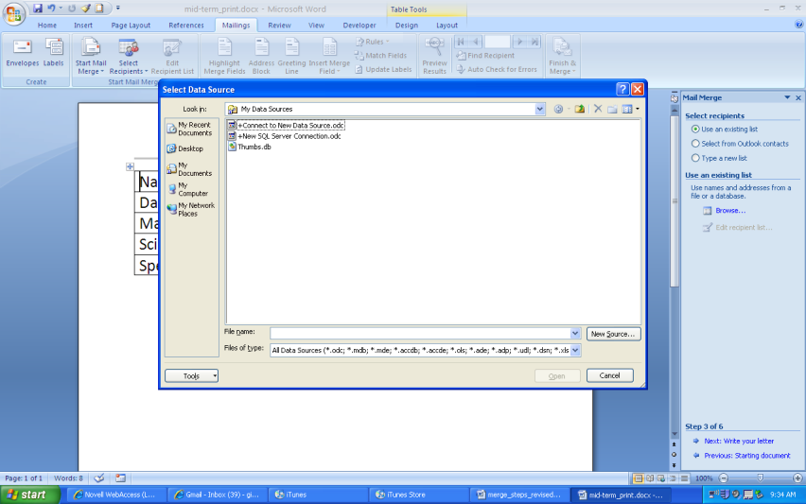
Look in the url field to locate your EXCEL document you created previously.
- Click: OK
- Select Sheet 1.
- Click: OK
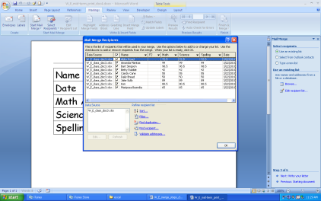
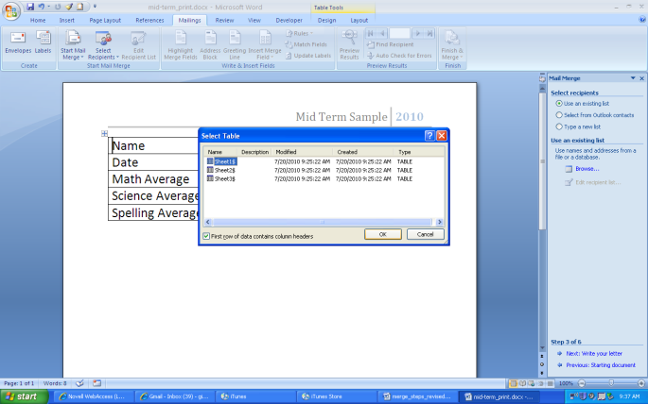
A new window pops up. Select: OK

- At bottom Select: Next: Write your letters (Step 3 of 6)
- In table move cursor to the first row 2nd column. (This is easy to forget to do)
- Select: More Items
Name | Chose items to go in these cells.
Date/Time
Spelling Average
Math Average
- Select: Name
- Select: Insert
- Select: Close
- Move Your cursor to the next field
- Select: More Items
- Select: Math
- Select: Insert
- Select: Close
- Move Your cursor to the next field
- Select: More Items
- Repeat
These items will be in different orders and you will have different topics.
Name
Date/Time
Spelling Average
Math Average

- At bottom select: Next – Preview your letters (Step 4 of 6)
- At bottom select: Next – Complete the merge (Step 5 of 6)
- Look up - Select: Edit Individual Letters (Step 6 of 6)
- A new window pops up asking how many reports to generate. (Window titled – MERGE TO NEW DOC) I chose to fill in each field with a range such as 1 -23.
- Select: OK
- Preview your letters (scroll down)
- Print when complete. Each midterm will print on its own page so you can include them in report card envelopes or send them home around midterm.

