**8:00 – 8:45 –** Welcome – Introductions

* Name
* Position
* School
* Expectations about this class
* Favorite Website
* **8:45 – 9:30 –** Websites to use today
  + [Virtual225Weebly](http://virtual225.weebly.com/flip-video-class.html)
  + Technology Standards

View Video – Information Overload Syndrome

Think – How does this apply to you?

View Motivational (Grandkids) & Anybody Can Use Smartboards – [Big Huge Labs](http://bighugelabs.com/) – Storybird - Gapminder

Think/Pair/Share – Using Blooms taxonomy as a resource what can students gain from these websites? –. (both as the consumers and the creators).

Build Your Wild Self, and Museum box- about Biome Related Food Chains.

Think/Pair/Share /Write – What challenges do you face to use online resources?

**9:30 – 9:45 –** Read Quietly –

* 10 Free, Must Have Web 2.0 Tools for Your Teaching & Training Needs
* Educational Technology and Mobile Learning – List of the best digital storytelling sites.

**9:45 – 10:15 -** Explore the Weebly – make note of your favorite or the most useful of the websites (at least 3).

**10:15 – 10:30 –** Break

**10:30 – 10:45 –** Speed Dating – Discuss ideas about how to use some of the websites in your classroom. Make notes. 3 minutes per rotation.

**10:45 – 11:30 –** Start a Symbaloo, Storybird, and a Tagxedo.

**11:30 – 12:30 -** Lunch

**12:30 – 12:45 –**View Video –Security Cameras

**12:45 – 2:00 –** Try Voki, Jigsaw Planet, and Tag Galaxy

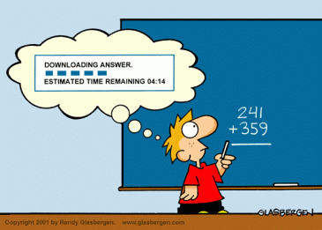

***2:00 – 2:30 –*** Share something you’ve learned today about one of the websites and how you can use it.

**2:30 – 3:00 –**

* Class evaluation form
* Blog
* What do you see as your next action steps?
* Questions
* Goodbye

Homework : After school starts you need to fill in the blog about how you used Wickedly Outrageous Websites with your students and how it worked. Deadline for this is October 31, 2012.

Remember – When all else fails!

